REF: SCI/AIMS/2026/014 DATE: 24 September 2026
The Director / Administrator
Abbas Institute of Medical Sciences (AIMS)
Muzaffarabad, Azad Jammu & Kashmir
SUBJECT SOFTWARE PLATFORM, DATABASE & SLA CONFIRMATION — AIMS HMS
Dear Sir / Madam,
SeeChange Innovative (Private) Limited hereby confirms that the Hospital Management System in use at Abbas Institute of Medical Sciences (AIMS), Muzaffarabad, was designed, developed and deployed by our company. The system has been fully operational since 2023 and has been upgraded regularly since then. Its current technical particulars are as follows:
Particular | Details
Application Type | Web-based, multi-user application (browser access over LAN / Internet)
Programming Language | PHP 8.x
Framework | Laravel 12 (open-source MVC framework)
Database (RDBMS) | PostgreSQL — open-source relational database
User Interface | Laravel Livewire 3, Alpine.js 3, Tailwind CSS 3, Blade templates
Authentication & Access | Laravel Jetstream / Fortify login; role & permission-based access control
Data Backup | Automated database and file backups (Spatie Laravel Backup)
Core Modules | Patient registration, OPD / IPD, emergency treatment, laboratory tests, fee & invoicing, government department billing, users & roles, daily / monthly reports

All application data (patients, admissions, tests, fees and transactions) is stored centrally in the PostgreSQL database. No proprietary or unlicensed software is used; all components are open-source.
Service Level Agreement (SLA): The system is maintained by SeeChange under a Service Level Agreement (SLA) at a charge of Rs. 15,000/- (Rupees Fifteen Thousand only) per month. The SLA covers:
• Regular Support: Monday to Friday, 9:00 AM to 5:00 PM — resolution of software issues, bug fixes, user and permission management, report corrections and minor enhancements.
• Emergency Support (24/7): round-the-clock response to critical failures, including server downtime, database issues and system unavailability.
• Server & Data Care: server monitoring, security updates, performance tuning and verification of PostgreSQL database backups.
Why the SLA is required: The SLA is necessary because the hospital depends on the system every day for patient registration, OPD/IPD, laboratory and billing. Continuous support keeps downtime to a minimum, protects patient and financial data, and keeps the system secure and up to date.
About SeeChange Innovative: SeeChange Innovative (Private) Limited is a registered software and IT consultancy company based in Lahore with a sub-office at SCO Software Technology Park, Muzaffarabad (AJK). It provides custom software development, web-based management systems, IT consultancy and digital solutions to public and private sector organisations (www.seechangeinnovative.com).
This letter is issued at the request of AIMS management for audit purposes. For clarification, please contact +92.335.999.1441 or contact@seechangeinnovative.com.
Sincerely,
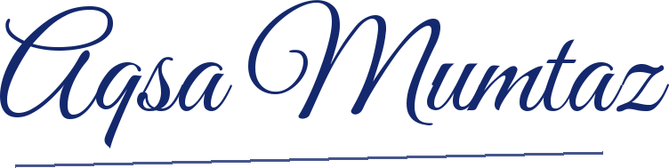
Aqsa Mumtaz
Chief Executive Officer
SeeChange Innovative (Private) Limited
Digitally signed on behalf of SeeChange Innovative (Private) Limited · 24 September 2026

